AI-BASED SMART IRRIGATION SYSTEM USING PYTHON AND ESP32

ABSTRACT

The proposed system presents an AI-Based Smart Irrigation System developed using an ESP32 microcontroller and Python programming for intelligent agricultural automation. The system continuously monitors environmental and soil conditions using multiple sensors, including a soil moisture sensor, DHT11 temperature and humidity sensor, rain sensor, water level sensor, ultrasonic sensor, and IR sensor. The collected sensor data is transmitted from the ESP32 to a Python-based application, where it is processed, stored in a database, and analyzed to generate intelligent irrigation recommendations. Based on real-time soil moisture and weather conditions, the system automatically controls a water pump through a relay module, ensuring efficient water usage while minimizing wastage. A web-based dashboard provides live monitoring, historical data visualization, system status, and AI-driven irrigation recommendations. The proposed solution is cost-effective, energy-efficient, scalable, and suitable for smart farming, precision agriculture, greenhouse management, and remote irrigation monitoring.

Dr. Aruna S K Dr.P. Vijayaragavan

THE FIELDOF INVENTION

The present invention relates to smart agriculture, Internet of Things (IoT), and artificial intelligence-based automation systems. More specifically, it pertains to the development of an intelligent irrigation system capable of monitoring soil and environmental conditions in real time using multiple sensors integrated with an ESP32 microcontroller and Python-based software. The invention combines embedded systems, wireless communication, cloud database technology, and AI-assisted decision-making to automate irrigation and improve agricultural productivity. It falls within the fields of precision farming, smart agriculture, environmental monitoring, and sustainable water resource management.

BACKGROUNDOFTHE INVENTION

Agriculture is one of the largest consumers of freshwater resources worldwide. Conventional irrigation methods often depend on manual operation or fixed schedules, resulting in excessive water consumption, uneven irrigation, and reduced crop productivity. Changes in weather conditions, soil moisture, and water availability make traditional irrigation methods inefficient and labor-intensive.
Recent advancements in IoT and artificial intelligence have enabled the development of intelligent agricultural systems capable of monitoring environmental conditions and automating irrigation processes. However, many existing solutions are expensive, require specialized hardware, or lack real-time decision-making capabilities.
The proposed invention addresses these limitations by introducing an AI-Based Smart Irrigation System using an ESP32 microcontroller and Python programming. The system continuously collects environmental data through multiple sensors, stores the information in a database, and automatically controls irrigation based on intelligent recommendations. This approach minimizes water wastage, reduces human intervention, improves crop health, and supports sustainable agricultural practices.

SUMMARYOFTHEINVENTION

The invention introduces an intelligent irrigation system capable of automatically monitoring and controlling irrigation using IoT technology and artificial intelligence. The ESP32 microcontroller acquires real-time data from soil moisture, temperature, humidity, rainfall, water level, ultrasonic, and IR sensors. The collected information is transmitted to a Python application where it is stored, analyzed, and displayed through an interactive dashboard.

Based on AI-generated recommendations and predefined irrigation logic, the system automatically activates or deactivates the water pump using a relay module. The dashboard provides live sensor monitoring, historical data visualization, irrigation recommendations, and system alerts. The device is compact, affordable, scalable, and suitable for farms, gardens, greenhouses, educational institutions, and precision agriculture applications. Future enhancements include machine learning-based crop prediction, weather forecast integration, mobile application support, cloud computing, and automated disease detection.

SPECIFICATION

- The system utilizes an ESP32 microcontroller for real-time data acquisition, processing, and wireless communication.
- A soil moisture sensor continuously measures soil water content to determine irrigation requirements.
- A DHT11 sensor measures ambient temperature and humidity for environmental monitoring.
- A rain sensor detects rainfall conditions and prevents unnecessary irrigation.
- A water level sensor monitors the availability of water in the storage tank.
- An ultrasonic sensor measures the water level or detects nearby obstacles based on project configuration.
- An IR sensor detects the presence of animals or unwanted objects entering the irrigation area.
- A relay module automatically controls the water pump based on sensor data and AI recommendations.
- A buzzer provides audible alerts during abnormal conditions such as low water level or animal detection.
- Python software processes sensor data, stores it in a database, and generates intelligent irrigation recommendations.
- A web-based dashboard displays live sensor readings, irrigation status, historical records, and system alerts.
- The system operates with low power consumption and supports future expansion through cloud connectivity, mobile applications, and machine learning integration.

DESCRIPTION

This project is an AI-Based Smart Irrigation System developed using an ESP32 microcontroller, multiple environmental sensors, and a Python-based monitoring application. The soil moisture sensor continuously measures soil conditions, while the DHT11 sensor monitors temperature and humidity. A rain sensor detects rainfall, a water level sensor monitors the availability of water in the storage tank, an ultrasonic sensor measures water level or distance, and an IR sensor detects the presence of animals or obstacles near the irrigation field.
The ESP32 collects sensor readings and transmits them wirelessly to a Python application connected to a database. The software processes the incoming data, generates AI-based irrigation recommendations, and displays the information through a web dashboard. When soil moisture falls below the required threshold and weather conditions are suitable, the relay module automatically activates the water pump. Once sufficient moisture is achieved or rainfall is detected, the pump is turned off automatically. A buzzer provides alerts during abnormal situations such as low water level or animal intrusion.
The system enables real-time monitoring, intelligent irrigation control, historical data storage, and efficient water management, making it suitable for smart farming, precision agriculture, research, and educational applications.
.

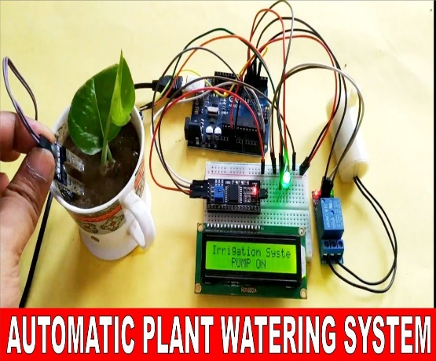
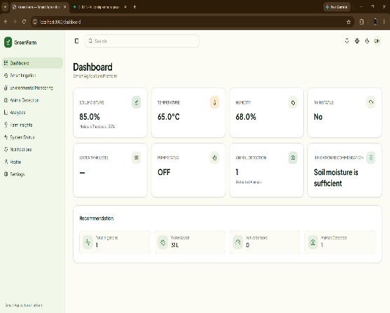

Figure1: Software Output
Figure2: Hardware Projecct

WE CLAIM

- An AI-based smart irrigation system capable of automatically monitoring soil and environmental conditions using multiple sensors and controlling irrigation in real time.
- The system of claim 1, wherein an ESP32 microcontroller acquires sensor data and communicates wirelessly with a Python-based monitoring application.
- The system of claim 1, wherein soil moisture, temperature, humidity, rainfall, water level, ultrasonic, and IR sensors are integrated for comprehensive environmental monitoring.
- The system of claim 1, wherein a relay module automatically controls a water pump based on intelligent irrigation decisions.
- The system of claim 1, wherein Python software stores sensor data in a database and generates AI-based irrigation recommendations.
- The system of claim 1, wherein a web dashboard provides live monitoring, historical data visualization, system alerts, and irrigation status.
- The system of claim 1, wherein the irrigation process minimizes water consumption while improving crop health and reducing manual intervention.
- The system of claim 1, wherein the system supports future enhancements including machine learning, cloud computing, mobile applications, weather forecasting, and precision agriculture technologies.

